**Technical Description: The Making of Scotch Whiskey**

**Introduction**

This technical description will detail the general process that is used to create the alcoholic beverage of Scotch whiskey. Commonly referred to simply as Scotch, it is a type of malt whiskey that is made from water and malted barley. While decisions in the process can change the percentage of alcohol in the beverage, Scotch typically has an alcohol by volume percentage (ABV) of 40 to 94.8%. The key, most crucial ingredient in all whiskies is barley, followed by water and yeast. The quality of these key ingredients is top priority in producing a high quality beverage.

For a whiskey to be considered pure Scotch whiskey, it must be distilled and produced in the country of Scotland and adhere to certain standards throughout its production. Furthermore, the specific location in Scotland where it is made can have drastic effects on the Scotch’s characteristics. The four main steps necessary to create Scotch include malting, mashing, fermentation, and distillation & maturation. It is then aged in specific types of wooden barrels for the distinct liquor flavor that Scotch whiskey is known for, and bottled and sold to the public.

**Figure 1. A map showing the regions that determine how a scotch is classified.**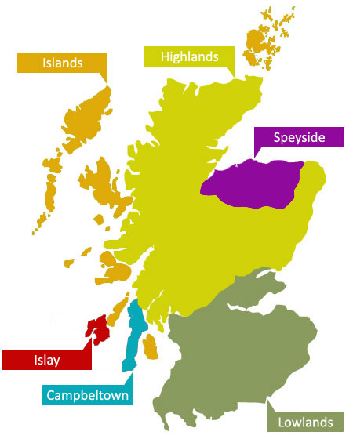

**Discussion**

1. **Malting**

The first step in the process of making the world-class beverage, known as Scotch whiskey, is the malt process. To begin, one must obtain the finest and highest quality barley to use to begin the process. The barley must be steeped, or soaked, in water to release its natural flavors and to allow it to soften for the following processes. Steeping occurs in steeping tuns, which are large tanks of water, and will take approximately 2 to 3 days. 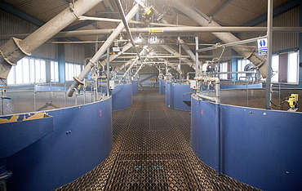

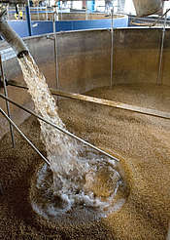

**Figure 2. Steeping tuns at the Port Ellen distillery in Islay**

**(Images of Port Ellen courtesy of Whiskey.com)**

After steeping, the barley is then laid out on a malt room floor to dry. As the barley dry, it will begin to germinate with the natural air and the addition of gentle heat. “Malting releases enzymes that break down starches in the grain and help convert them into sugars. When the desired state of germination is reached, the barley is dried using the traditional kiln floor” (*WhiskeyIntelligence*). It can take the barley from 8 days, **Figure 3. Steeping barley at Port Ellen**  up to around 12 days to properly germinate. “During germination the barley secretes the enzyme diastase which makes the starch in the barley soluble, thus preparing it for conversion into sugar”, (http://www.dcs.ed.ac.uk).

The barley must be turned regularly to prevent the excessive build-up of heat. Turning the barley can be done in several ways. The traditional method of turning barley is by use of a wooden shovel, or specialized rake. More common methods now involve the use of machinery and mechanical equipment to automatically turn the barley. However, there are still some distilleries that turn barley by using the old fashioned methods.

“At the appropriate moment germination is stopped by drying the malted barley or green malt in the malt kiln. Temperature is controlled by blowing air at selected temperatures upwards through the germinating grain, which is turned mechanically. A recent development caused by the rapid expansion of the Scotch Whisky Industry is for distilleries to obtain their malt from centralised maltings which supply a number of distilleries, thereby enabling the malting process to be carried out more economically” (http://www.dcs.ed.ac.uk). 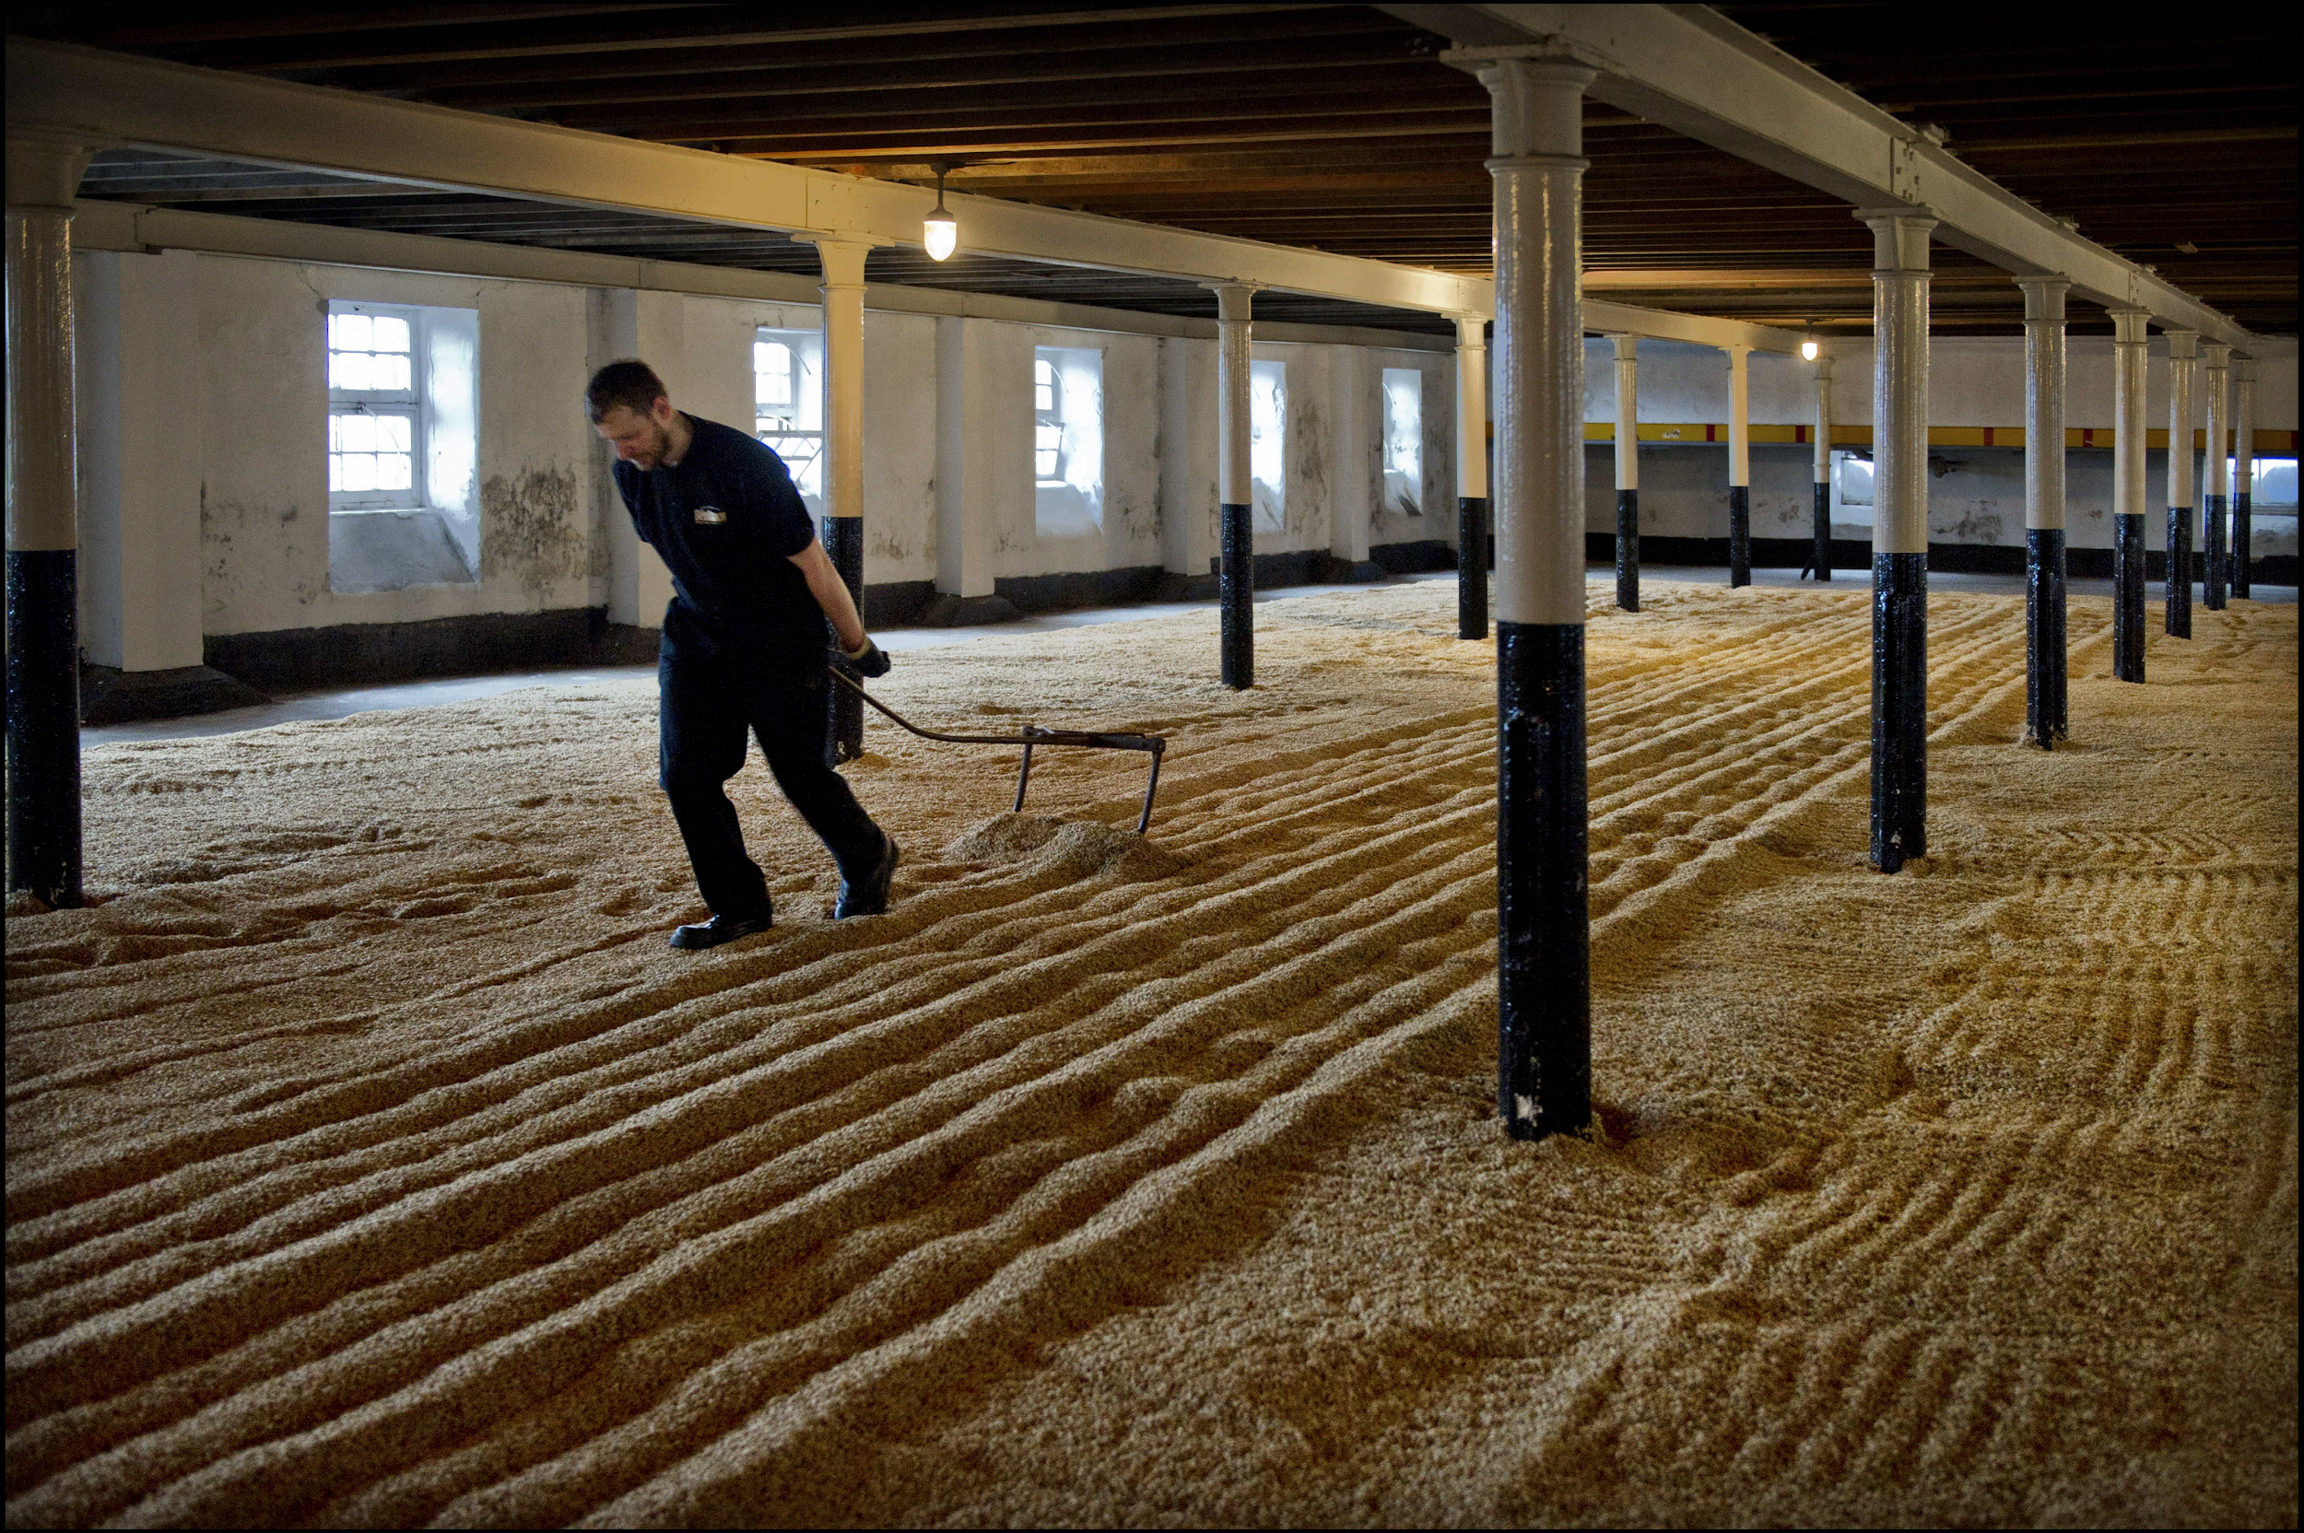

**Figure 4. A worker at Benriach distillery in Elgin, United Kingdom, uses a tool to turn barley by hand. Images courtesy of WhiskeyIntelligence.com**

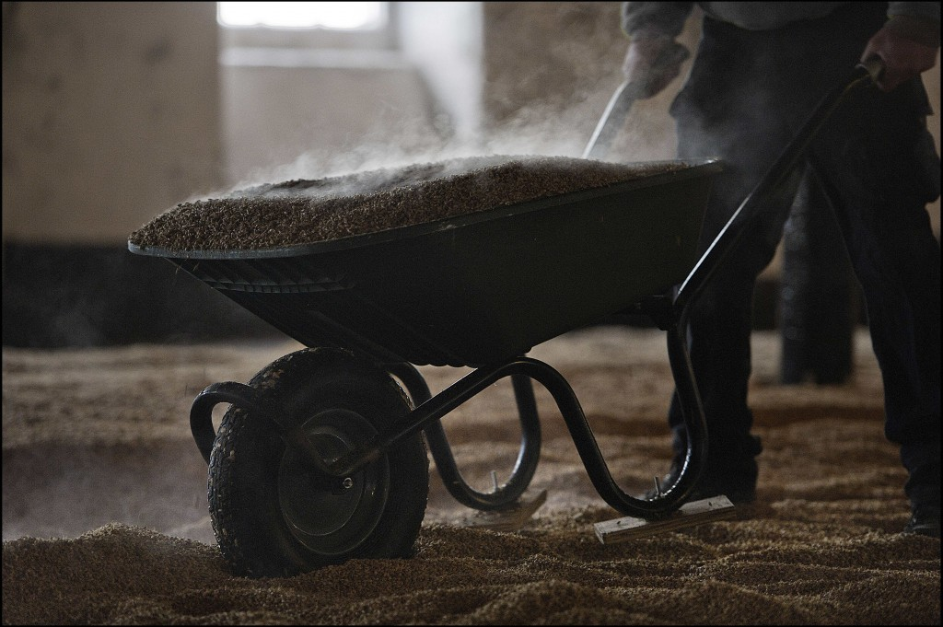

**Figure 5. Another worker at the Benriach distillery uses a common wheelbarrow to turn steaming heaps of barley.**

1. **Mashing**

The second step in the process of making scotch whiskey is mashing. Mashing is “the link between malting and fermentation”(Mashing, Whiskey.com). Dried malt is ground in a mill and then the grist is mixed with hot water in a large circular vessel called a mash tun.

The tun is forged usually of steel or copper but more often than not steel is used. This is because of the price of material of copper rising. The sides of the tun is insulated for better temperature control. The bottom is made of plates.

A depiction of a mash tun can be seen below in figure 1 of the mashing process.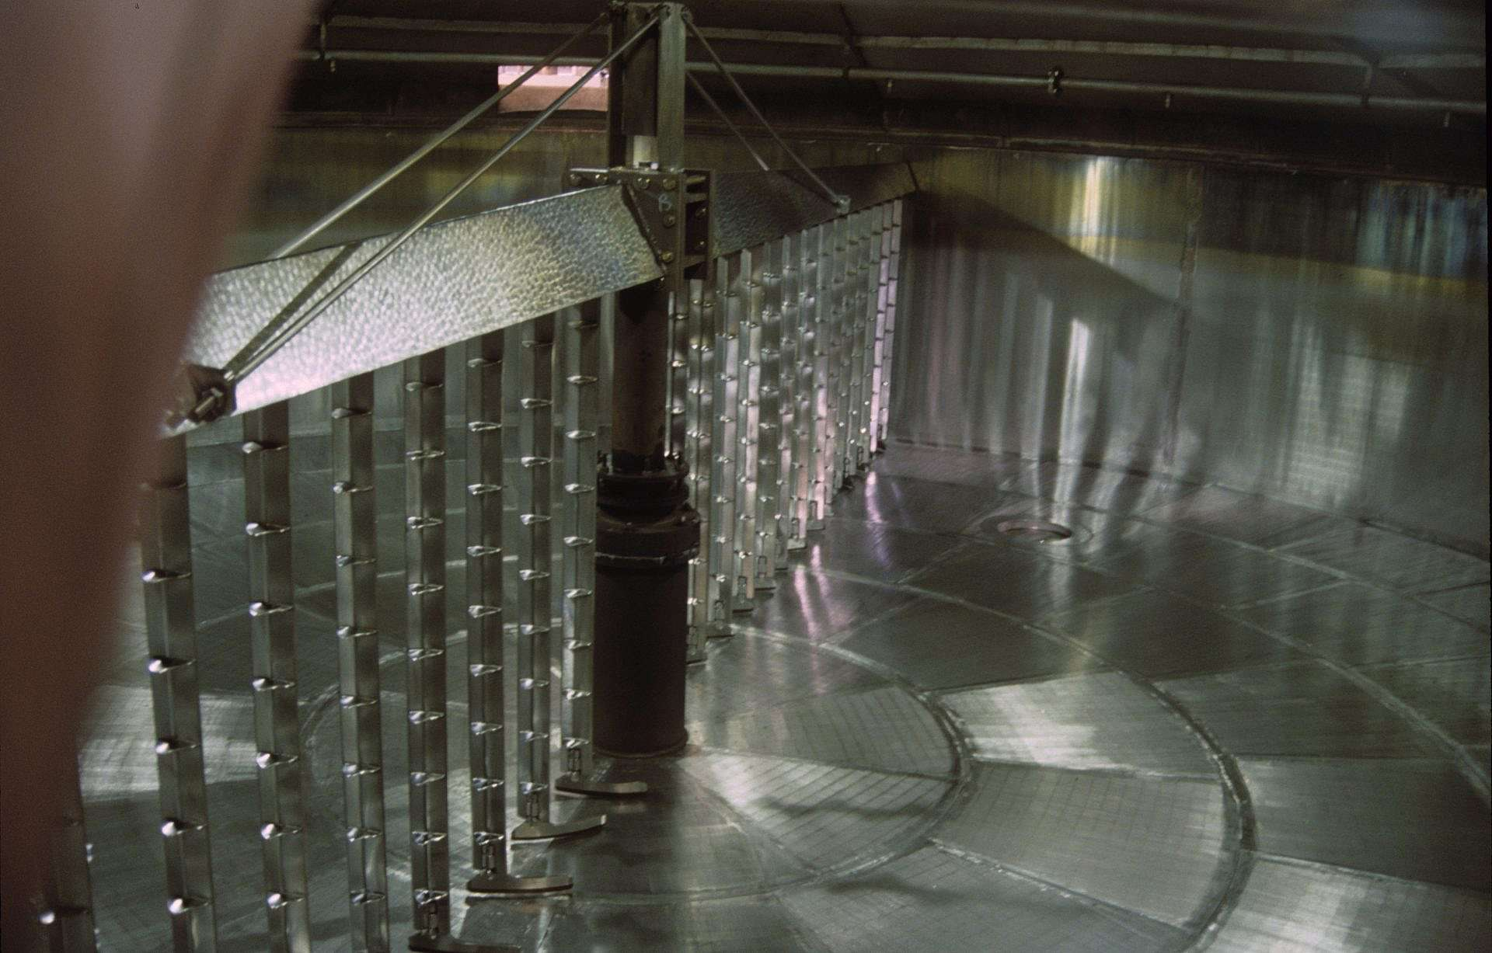

**(Mashing Process Figure 6 (Mashing, Whiskey.com))**

The mashing process can be broken down into steps and it is essential that each step is done before the next.

The first step in the mashing process is getting the hot liquor warmed to the strike temperature. The strike temperature is between “68-70 degrees Fahrenheit” (CrispMalt.com). This is to ensure the mash temperature is around 64 degrees. Any high levels of water need to be removed. This can be done easily with softeners.

After the liquor is the correct temperature the next thing that should be done is to fill the mash tun with the correct amount of hot liquor. A good estimation would be to cover the bottom plates with a couple inches of depth. The malt and water must be mashed for an adequate amount of time, roughly 20 minutes. Afterwards the bed layer can be rested for up to an hour to allow the starch to turn into sugar. Once rested the wort can be re-added back into the tun which will be “drawn off from the mash tun in a controlled manner, ensuring that the runoff speed is not so fast as to pull the bed down onto the plates and therefore cause a stuck mash”(CrispMalt.com). This wort will be used in the next step, fermentation.

1. **Fermentation**

The third step in the process of making Scotch whiskey is fermentation. Alcoholic fermentation is a chemical reaction in which carbohydrates are converted into alcohol. Since fermentation is performed by microorganisms, yeast is added to the wort created in the mashing process. Over the course of 48-96 hours, the carbohydrates in the wort mix and react with the yeast to create a substance at the end of the fermentation process called “distiller’s beer”.

In order to understand how alcohol is produced from simple grains, one must understand the complex chemistry behind fermentation. Fermentation is an anaerobic chemical reaction, meaning it does not require oxygen to occur. The input is glucose, a simple sugar molecule with a chemical composition of 6 carbon atoms, 12 hydrogen atoms, and 6 oxygen atoms (C6H12O6). When mixed with yeast, a single-celled fungus, the glucose molecules undergo glycolysis, where enzymes in the yeast break down the glucose to create pyruvic acid and energy from the breaking of chemical bonds (Khan Academy). Pyruvic acid, also called pyruvate, has the chemical composition C3H4O3, and as such, two pyruvic acid molecules can be decomposed from one glucose molecule. From these two pyruvic acid, a byproduct of two ethyl alcohol molecules (C2H5OH) and two carbon dioxide (CO2) are created. This ethyl alcohol, also referred to as ethanol, is what gives the Scotch its alcoholic content.

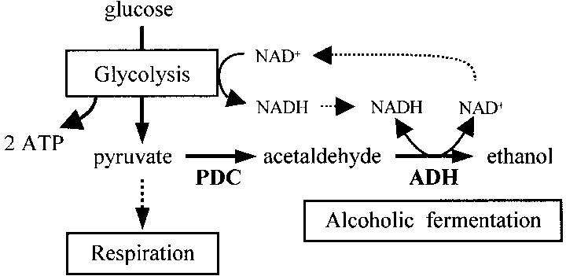

**Figure 7. A diagram showing the breakdown of alcoholic fermentation.**

In the process of making scotch, fermentation comes directly after mashing. The end result of mashing is a liquid called wort. The wort is immediately cooled from its near-boiling temperature to around 20° Celsius (68°F). Since the microorganisms in the yeast cannot survive at high temperatures, cooling the wort ensures it does not kill the yeast before fermentation can take place. Once cooled, the wort is poured into large tanks called washbacks. Washbacks can be made of either a metal, such as stainless steel, or wood. Some scotch distilleries that have been operating for several hundreds of years still use wooden washbacks to maintain consistency in their product output. However, if wooden washbacks are in use, they must be rigorously cleaned before pouring in each batch of wort, as the material and warm environment are ideal for unwanted bacteria growth. Cleaning is performed by steaming the tanks at extremely high temperatures in conjunction with cleaning detergents. A thorough cleanse of the washbacks in between batches is vital to ensuring that fermentation will properly take place. Without one, a bacteria known as lactobacillus will perform its own decomposition of the barley’s carbohydrates where alcohol is not produced (The Whisky Professor).

**Figure 8. An empty wooden washback with a blade that is used to stir the liquid and remove foam.**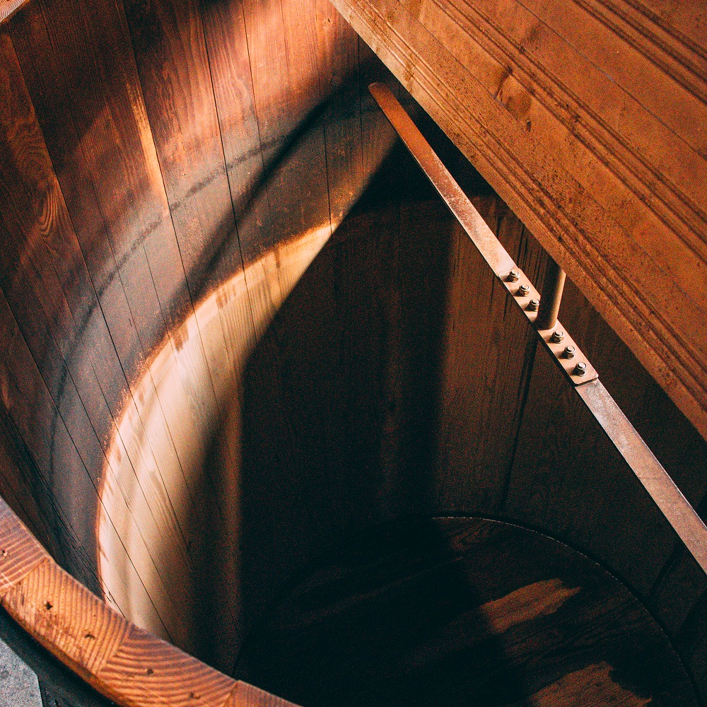

The washbacks are where yeast is added to the wort and fermentation begins to take place. Yeast is typically added at a ratio of 1 kilogram per 300 liters of wort (Whisky.com). Large blades in the washback slowly spin to mix the wort and yeast, ensuring an even distribution. The chemical reaction occurs, with the yeast decomposing the carbohydrates from the malted barley and slowly making it into ethanol.

Large-scale alcoholic fermentation releases a considerable amount of carbon dioxide due to cellular respiration. In fact, so much carbon dioxide is produced that being in the room can be dangerous to humans if not properly ventilated. Therefore, the room containing the washbacks have either pipes to each individual washback to extract the carbon dioxide, or a ventilation system for the entire room (Undiscovered Scotland). The carbon dioxide rises to the top of the tank, creating a layer of foam that can be seen in Figure 5. The aforementioned blades that some washbacks have at the top (visible in Figure 8) are present to remove this top layer of foam, should it become close to overflowing the top of the tank.

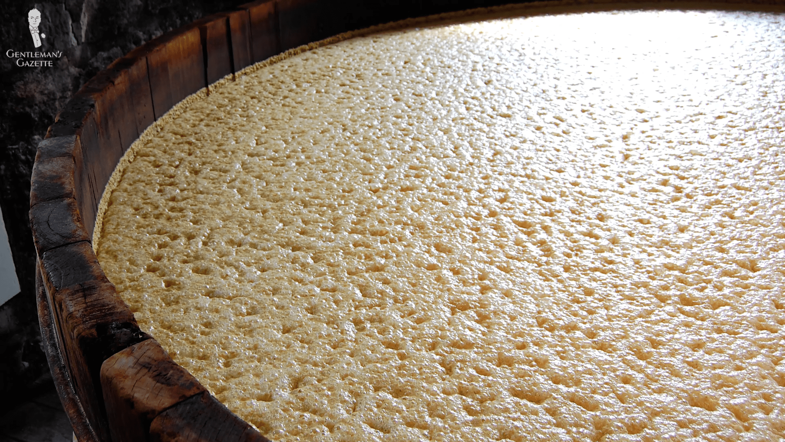

**Figure 9. A washback full of distiller’s beer at the end of fermentation.**

The wort and yeast solution is left to ferment for at least two days. From then on, the solution, known at this point as distiller’s beer, can either be immediately removed from the washback or left for an additional period of time to continue fermenting. The amount of time fermenting can determine the qualities of the end result (Whisky.com). For example, a wort that is fermented for an amount of time close to the minimum of forty-eight hours will result in an end product with stronger cereal flavors. Since the wort is given less time to develop with the yeast, the prevailing flavor is still of the grains that were malted and mashed. Longer fermentations tend to last anywhere from sixty to ninety-six hours, and will result in a fruitier flavor in comparison.

Once the distiller’s beer is removed from the washbacks, the fermentation process is complete. Distiller’s beer has an ABV of anywhere between 6-10% (Whisky.com). From here, the distiller’s beer is pumped to the pot stills for distillation.

1. **Distillation & Maturation**

The fourth and final step is distillation and maturation. Distillation is the process of purifying a liquid by heating and cooling. Maturation is the process of chemical reactions taking place between the alcohol and the wood of the casks. Most Scotch whiskey is distilled twice in copper pot stills. The wash goes into the first pot still, which is called the wash still, where the wash is heated slowly to separate the alcohol from the water. The wash is heated to 78 degrees Celsius since the boiling point of alcohol is 78 degrees Celsius, whereas the boiling point of water is 100 degrees Celsius. The alcohol vapors travel through tubes at the top of the pot still where it travels to a condenser to turn the vapor back into a liquid. The pot stills are shown below in Figure 10. From the condenser, the alcohol collects in the second pot still, called the spirit still. The total time it takes for the first distillation to occur is typically four to eight hours.

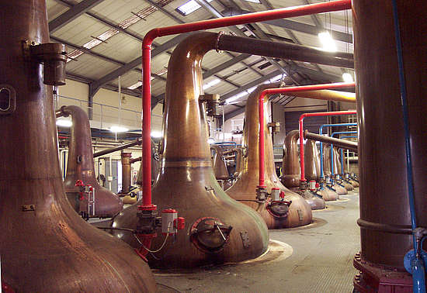

**Figure 10. The Pot Stills of Glenfiddich**

After the first distillation, the liquid in the second pot still contains somewhere between 20%-25% alcohol, which is called a low wine (Whisky.com). The same process occurs in the second still as in the first still, but since there is less water in the second still, the resultant liquid will contain somewhere between 65% and 70% alcohol by volume. Both the wash still and the spirit still are identical to each other. Some distillers even distill this liquid a third time creating a higher alcohol content, but the majority only distill their Scotch twice. The alcohol vapors from the spirit still travel through tubes where it travels to a condenser that will turn the vapor into a liquid again. This liquid is then collected into a spirit safe where the liquid can then be transported into the casks for maturation (Whisky.com). Figure 11 shows an engineering drawing of Vendome 500 gallon pot still.

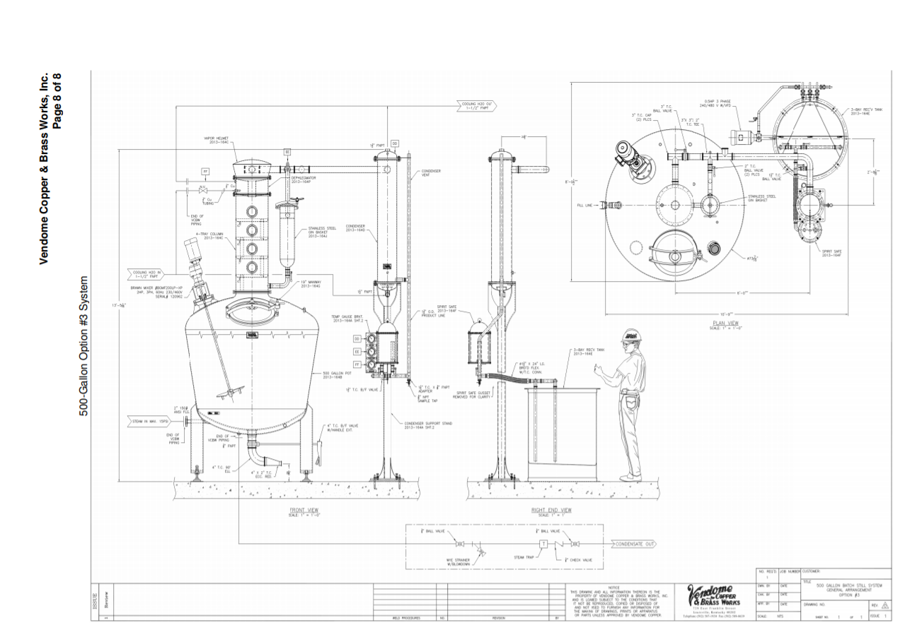

**Figure 11. Vendome 500 Gallon Copper Still**

Scotch whiskey can only be considered Scotch if it has matured for three years or longer. Most Scotch whiskies will actually mature for ten or more years. The whiskey matures in large wooden barrels, called casks. The filling of the casks in shown below in Figure 11. The casks are exclusively made out of oak wood for its breathability and durability. The quality of the wood is also important, as the wood the cask is made of will also change the composition of the Scotch over time. For example, material from the cask’s inner walls slowly infuses with the Scotch to give it a “wood-y” taste. The casks used to mature the Scotch whiskey have previously been used to mature various types of alcohol. Some distilleries use casks that were previously used to mature bourbon, sherry, rum, and other spirits. Besides the origin of the casks, the environment the casks mature in is also important. Some distilleries store the casks in old warehouses that have no heating or cooling which will affect the maturing process differently than modern warehouses that have heating and cooling. Another factor is the location of the distilleries and the climate there. The Scotch will mature differently in the highlands than the coast of Scotland, since the highlands have hot summers and cold winters, while the coast has a mild climate from the gulf stream.

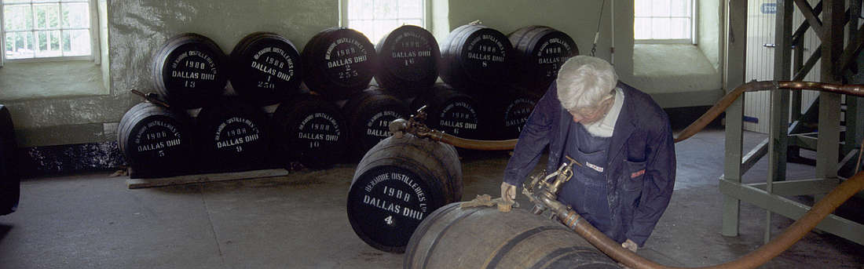

**Figure 12. Filling of Casks at Glenturret**

When the whiskey goes into the casks, the alcohol content is usually around 63%-64% alcohol by volume. Over the process of maturing, the alcohol content of the Scotch will decrease, generally around 0.2%-0.6% per year. The people of Scotland call the evaporated alcohol the “Angel’s Share” (Whisky.com). The overall level of the alcohol contained in the cask decreases by 2% each year. With the alcohol evaporation and chemical reactions between the whiskey and the wood of the casks, the Scotch mellows more and more every year. A couple times a year, a sample will be taken from each batch to determine if the Scotch has reached its prime. With each use of the casks, the flavoring absorbed from the cask will diminish with every use. Because of this, when creating a final product, the distillers will blend several different casks together so that each bottle will taste the same.

**Conclusion**

Scotch whiskey is a liquor that is renowned by many distilling enthusiasts all over the world for its unique production process and characteristics. The long aged taste is delivered in a way that is unlike any other drink. This is due to the process of malting, mashing, fermentation and distillation. The soaking and cooking of the grains prepares them to . Mashing is where the grains, which in malt whiskeys such as Scotch is exclusively barley, are mashed in a large container with hot water until enough sugar is extracted the wort is moved on to the next process. Fermentation produces the alcoholic content of the Scotch, developing the grains by changing their chemical composition. Distillation and the subsequent aging concentrates the liquid until it reaches the distiller’s desired composition. Though making Scotch is an involved task with many places for things to go wrong, there is clearly value in its creation. Scotland has developed a rich heritage based around the beverage, and it will continue to carry on. What started as a local tradition has now become a small aspect of Scotland’s culture that is enjoyed all over the world.

**Works Cited**

“1,4-Dihydronicotinamide Adenine Dinucleotide.” *National Center for Biotechnology Information.*

*PubChem Compound Database*, U.S. National Library of Medicine,

pubchem.ncbi.nlm.nih.gov/compound/1_4-Dihydronicotinamide-adenine-dinucleotide.

“BENRIACH RE-STARTS ITS OWN MALTINGS – Scotch Whisky News .” *WhiskyIntelligence.com*, 8 Nov. 2012, <http://www.whiskyintelligence.com/2012/11/benriach-re-starts-its-own-maltings-scotch-whisky-news/>.

“Crisp the Finest Malt.” Crispmalt.com, bsgcraft.com/Resources/Product_Sheets/Crisp/Crisp%20Malt%20Scotch%20Distilling%20Mash%20Protocol.pdf.

“Distillation.” *Scotch - Distillation - Whisky.com*, [www.whisky.com/information/knowledge/production/overview/how-single-malt-whisky-is-made/scotch-distillation.html](http://www.whisky.com/information/knowledge/production/overview/how-single-malt-whisky-is-made/scotch-distillation.html).

“Fermentation and Anaerobic Respiration.” *Khan Academy*, Khan Academy, [www.khanacademy.org/science/biology/cellular-respiration-and-fermentation/variations-on-cellular-respiration/a/fermentation-and-anaerobic-respiration](http://www.khanacademy.org/science/biology/cellular-respiration-and-fermentation/variations-on-cellular-respiration/a/fermentation-and-anaerobic-respiration).

“Mashing.” *Mashing - Whisky.com*,

www.whisky.com/information/knowledge/production/details/mashing.html.

“Port Ellen.” *Whiskey.com Where Fine Spirits Meet*, Whisky.com Media GmbH & Co. KG, <https://www.whisky.com/whisky-database/distilleries/details/port-ellen.html>.

Professor, The Whisky. “Are Wooden Washbacks Better than Steel?: Scotch Whisky.” *Scotchwhisky.com*, 16 May 2016, scotchwhisky.com/magazine/ask-the-professor/9275/are-wooden-washbacks-better-than-steel/.

“Scotch Fermentation.” *Scotch - Fermentation - Whisky.com*, [www.whisky.com/information/knowledge/production/overview/how-single-malt-whisky-is-made/scotch-fermentation.html](http://www.whisky.com/information/knowledge/production/overview/how-single-malt-whisky-is-made/scotch-fermentation.html).

“Section 3: Scotch Whisky in the Making.” *School of Informatics / The University of Edinburgh*, © SWA , 1995, <http://www.dcs.ed.ac.uk/home/jhb/whisky/swa/chap3.html>.

Undiscovered Scotland: “Undiscovered Scotland.” *Undiscovered Scotland: Making Malt Whisky: The Washback*, [www.undiscoveredscotland.co.uk/usfeatures/maltwhisky/washback.html](http://www.undiscoveredscotland.co.uk/usfeatures/maltwhisky/washback.html).